

Substance Abuse

|  |  |  |  |  |  |
| --- | --- | --- | --- | --- | --- |
| HOME |  | Services | Events | Officials | Contact Us |

Prevention and Rehabilitation



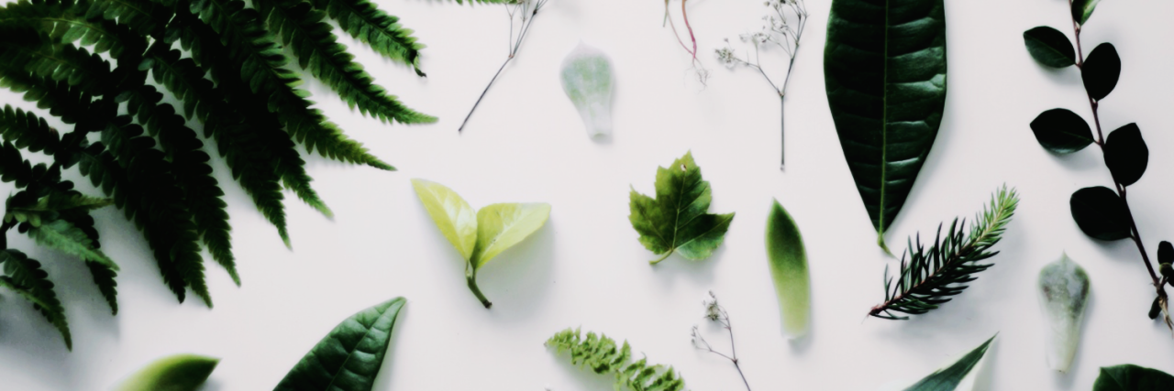

**Substance Abuse** pertains to excessive use of psychoactive substances such as legal drugs: alcohol and tobacco, and illegal drugs: cannabis aka marijuana, heroin, ecstasy, cocaine and methamphetamine aka shabu.

Bonifacio – Caguia – Rimando

~News~



**Prevention is needed, substance abuse causes**